SQL QUERIES

(1) Creating and using the database : CREATE command is used to create a table, database etc.. DATABASE is used to define the database and USE is used to use the particular database.The CREATE DATABASE statement is used to create a new SQL database.

Syntax :

create database database_name;

use database_name;

Example :

create database hello;

use hello;

(2) Creating a table : To create a table we use CREATE and TABLE keywords. The CREATE TABLE statement is used to create a new table in a database.

Syntax : create table table_name(value1 datatype1, value2 datatype2, value3 datatype3);

Example :

create table student(id int, fname varchar(50), lname varchar(50), dept varchar(50));

select * from student;

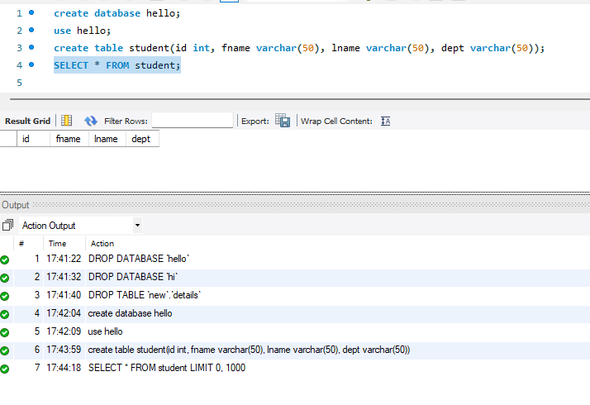

(3) Insert values into tables: To insert values into table we use INSERT INTO and VALUES keywords. We can specify both the column names and the values to be inserted at the same time. The INSERT INTO statement is used to insert new records in a table.

insert into table_name (column1, column2, column3,...) values (value1, value2, value3, ...);

Syntax : insert into table_name values(value1, value2, value3);

Example :

insert into student values(1, "Gayathri", "Nuthalapati", "CSE");

insert into student values(2, "Ramya", "Tadepalli", "EEE");

insert into student values(3, "Kranthi", "Pulugu", "ECE");

insert into student values(4, "Priya", "Nalam", "CIVIL");

insert into student values(5, "Nikhitha", "Kondaveeti", "MECH");

(4) Select all rows from table : To select all the rows from table we use SELECT, FROM and * and name of table from which we want to extract the data.The SELECT statement is used to select data from a database.The data returned is stored in a result table, called the result-set.

Syntax : select * from table_name;

Example : select * from student;

(5) Where statement : WHERE keyword is used to define some conditions.This clause is used to filter records.It is used to extract only those records that fulfill a specified condition.

Syntax : select column_name from table_name where condition;

Example :

select * from student where lname="Nalam";

select * from student where id >=1;

(6) OrderBy : The ORDER BY keyword is used to sort the result-set in ascending or descending order.The ORDER BY keyword sorts the records in ascending order by default. To sort the records in descending order, use the DESC keyword.To sort the records in ascending order, use the ASC keyword.

Syntax : select * from table_name order by asc|desc;

Example :

select * from student order by dept;

select * from student order by id;

select * from student order by id desc;

(7) Count : The COUNT function returns the number of rows that matches a specified criterion.  
Syntax : select count(column_name) from table_name;

Example : select count(fname) from student;

(8) Delete : The DELETE statement is used to delete existing records in a table.

Syntax : delete from table_name where condition;

Syntax to delete all rows : delete from table_name;

Example :

delete from student where fname = "Priya";

delete from student;

(9) Primary key : The PRIMARY KEY constraint uniquely identifies each record in a table. Primary keys must contain unique values, and cannot contain null values. A table can have only one primary key; and in the table, this primary key can consist of single or multiple columns (fields).

Syntax : item primary key;

Example :

create table studentmarks(id int not null primary key, phy int, che int, maths int);

insert into studentmarks values(1, 98, 77, 67);

insert into studentmarks values(98, 77, 67);

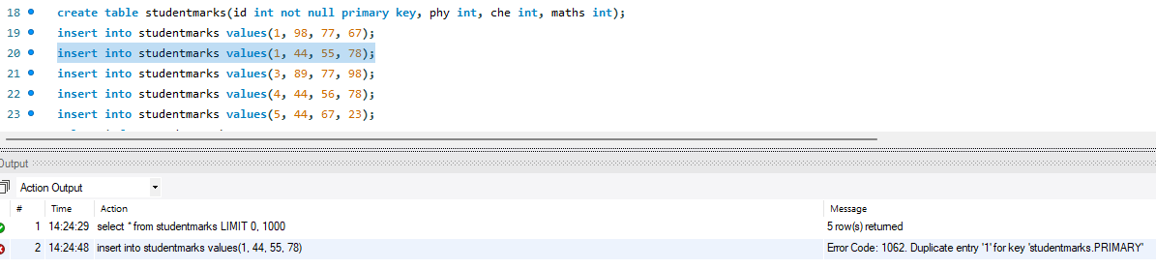

(10) Foreign key : The FOREIGN KEY constraint is used to prevent actions that would destroy links between tables. A foreign key is a field (or collection of fields) in one table, that refers to the [primary key](https://www.w3schools.com/sql/sql_primarykey.asp) in another table. The table with the foreign key is called the child table, and the table with the primary key is called the referenced or parent table.

Syntax : foreign key (item_as_primary_key_in_another_table) references parent_table(item);

Example :

create table studentrankings(id int, ranks int, foreign key (id) references studentmarks(id));

insert into studentrankings values(1, 1);

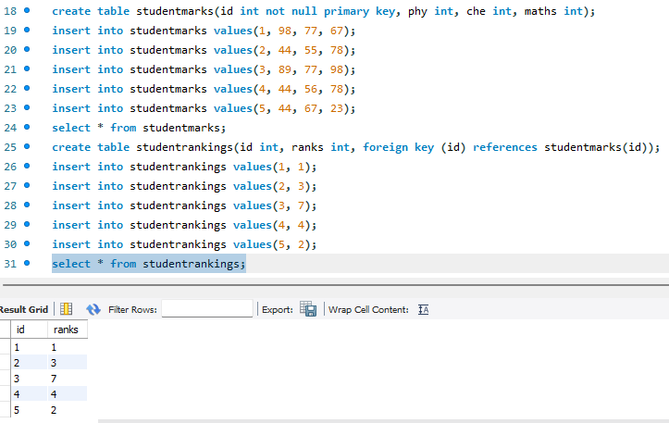

(11) Truncate table : The TRUNCATE TABLE statement is used to delete the data inside a table, but not the table itself.

Syntax : truncate table table_name;

Example : truncate table student;

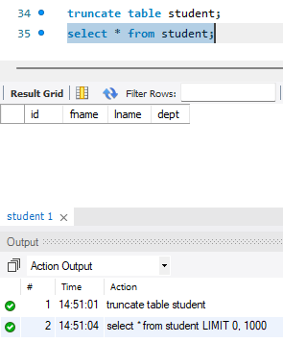

(12) Unique : The UNIQUE constraint ensures that all values in a column are different. Both the unique and primary key constraints provide a guarantee for uniqueness for a column or set of columns. A primary key constraint automatically has a unique constraint. However, you can have many unique constraints per table, but only one primary key constraint per table.

Syntax : unique (column1, column2, column3);

Example :

(13) Join : A JOIN clause is used to combine rows from two or more tables, based on a related column between them.

1. Inner join :

Syntax :

Example :

2. Left join :

Syntax :

Example :

3. Right join :

Syntax :

Example :

4. Full cover join :

Syntax :

Example :

(14) Drop table : The DROP TABLE statement is used to drop an existing table in a database. Here deleting a table will result in loss of complete information stored in the table.

Syntax : drop table table_name;

Example : drop table student;

